**PhDr. Vojtěch Mojžíš - How was Forfest Kroměříž 2023**

Review by a leading Czech musicologist for the prestigious music magazine Harmonie

In Kojetín, which is not far from Kroměříž, the last concert of this year's 34th Forfest Kroměříž took place on September 21. Alois Hába was remembered at the Art School there, which is housed in beautiful, recently built premises. We remember the composer on the occasion of this year's 130th anniversary of his birth and 50th anniversary of his death. Pianist **Miroslav Beinhauser** concentrated exclusively on Hába work in his recital. At the beginning he included Four Modern Dances, Op. 39 and Shimmy – Fox, followed by Two Pieces for Piano, Op. 2 and before the break Three Fugues. In the second part of the evening, the audience heard Romance and Waltz, Six Moods, Op. 102. The recital was closed by Háb's Variations on the Canon by Robert Schumann, op. 1b.

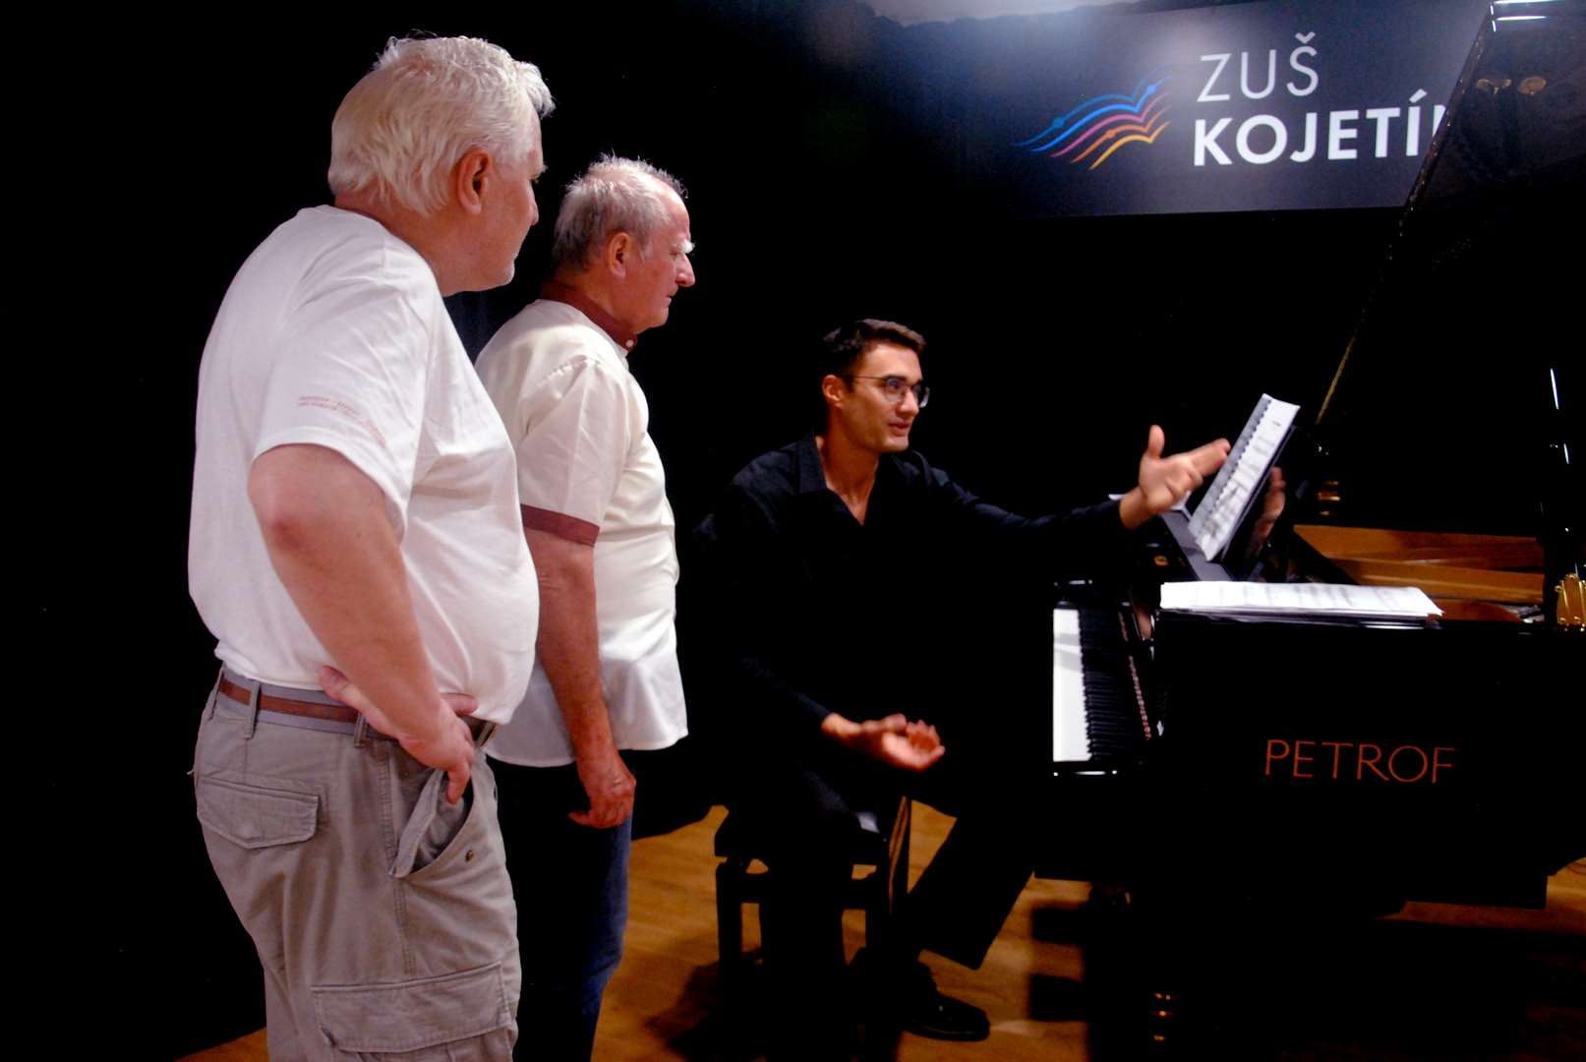

Discussion with composers and musicologists PhDr. Vojtěch Mojžíš and Doc. Jan Grossmann

Already the entry op. 39 took us to the borderlands of serious and jazz music of the interwar period. This work - Shimma-Blues, Boston, Tango and Shimma-Fox, which few would have expected from Hába, was written in 1926. The thirty-three-year-old author masterfully grasped the proper genre characteristics of the dances, enriching their metrorhythms with his own spontaneous invention. Op. 2. presents a completely different world. It works with an extended tonality and is saturated with subtle fantasy. Evidence of Háb's compositional mastery can be his Three Fugues, on which one can admire not only his mastery of the traditional type of compositional work, but also his originality in the choice and elaboration of themes, which he often elaborates to pathetic positions. Although he was not a pianist, his stylizations are unusually rich and well-sounding.

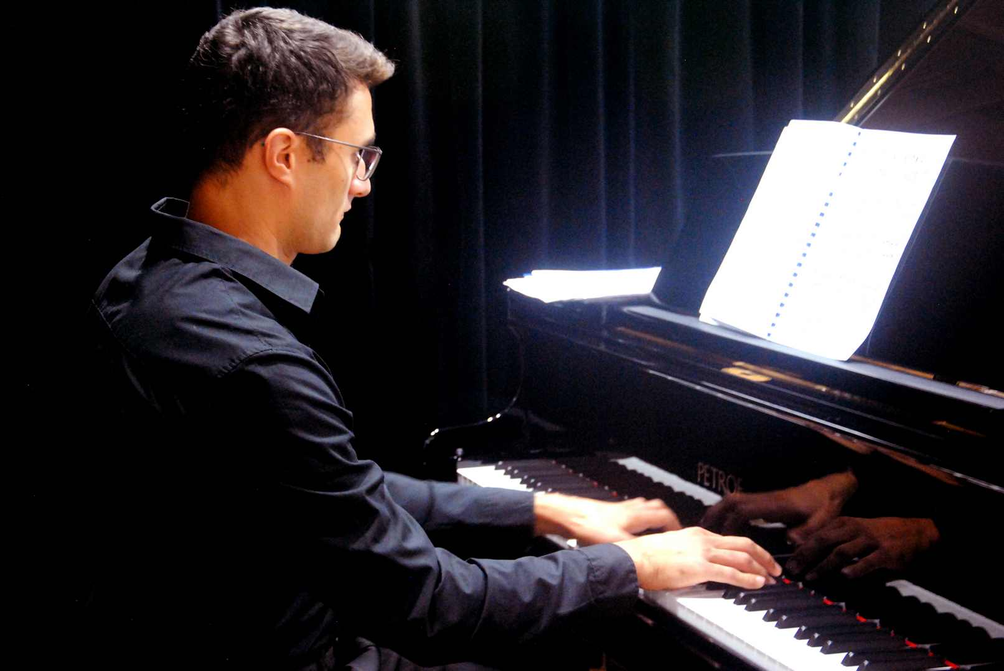

Piano recital of Miroslav Beinhauer 2023

Háb's diptych Romance and Waltz is also characterized by its dramatic climax and inner poetics.

Six Moods, Op. 102 was written by Alois Hába in 1971 for the brilliant pianist Emma Kovárnová, a member of the ensemble Due Boemi, who requested the original work from the composer for her solo presentation with the bass clarinetist Josef Horák, her permanent concert partner. The concert took place on January 8, 1972, and Moods was performed at the premiere. It is a cycle of short, lapidary movements in which the pianist could convincingly demonstrate the colourfulness, precision and diversity of her interpretive art. The conclusion of the evening belonged to Háb's first opus, a cycle of variations on a theme by Robert Schumann. It ends with a magnificent fugue.

Miroslav Beinhauer penetrated deeply into Háb's piano style and delicately accented the leading melodic lines during the interpretation. He thus made both Háb's polyphonic structures and his homophonic compositions plastic and clear. After the last notes of the program, the pianist talked with the audience. He talked about the program's compositions, all of which were composed in a semitone system. However, he also focused his interpretation on promoting Háb's original idea of applying microintervals. In this direction, however, he remained without sound samples - for understandable reasons, as he had no micro-interval instrument at his disposal at this concert. In spite of this, he introduced his listeners to his efforts to promote Háb's quarter-tone work. However, he also recalled his experiments with Háb's six-note structures, sounded through Háb's unique musical instrument, the six-note harmonium. He referred to his experience with this instrument, which is part of the exhibition of the Czech Museum of Music in Prague.

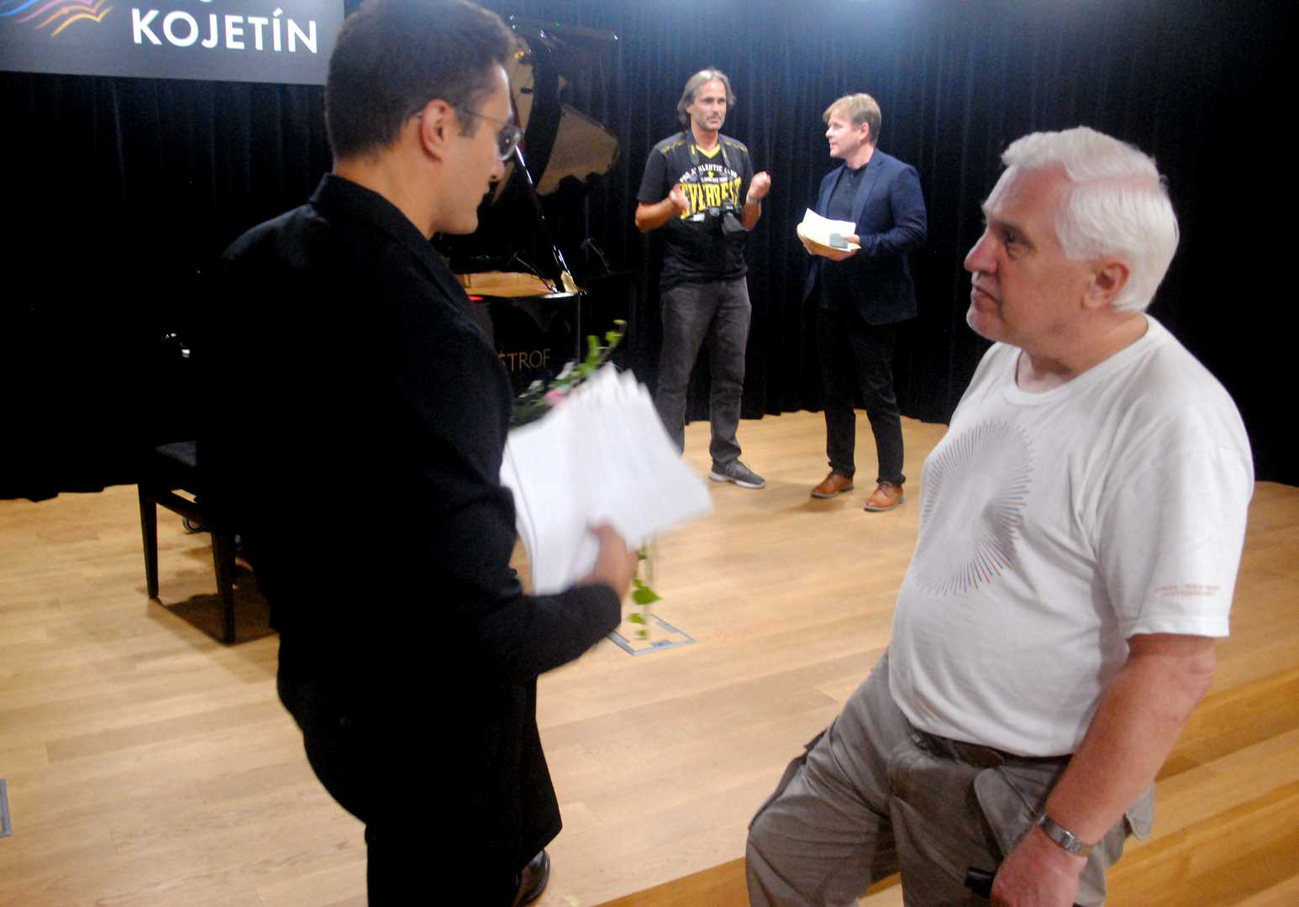

Miroslav Beinhauer's recital 2023 - discussion with Doc. Jan Grossmann after concert

So that was the end of Forfest 2023, but what was its beginning?

Festival also took place in Kojetín and was also focised on works by KarelHába. On March 4, a public recording of the Karel Hába project for children took place there. Music parts of instructional literature from Alois Hába's brother, Karel Hába, were taken over by children from the local music institute.

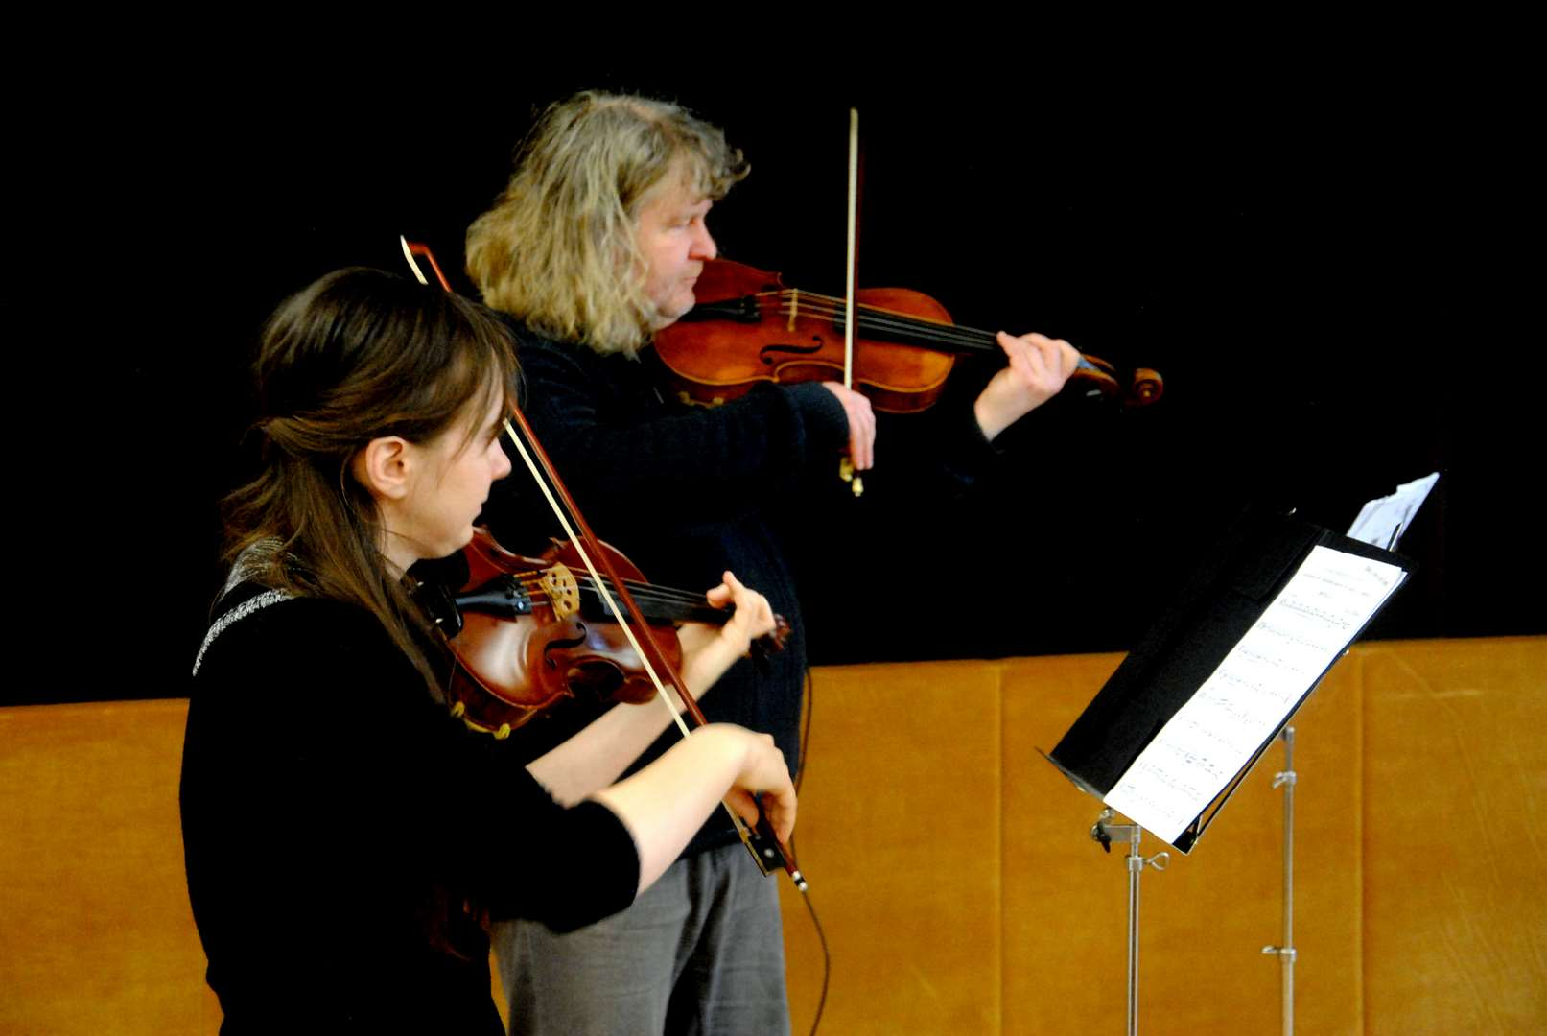

From recording of music by Karel Hába 2023 – Anna Jeklová, Petr Vaculovič - Kroměříž Museum

Music for children was played at the Kroměřížska Museum on April 1 as part of a composition project by the composer Josef Adamík.

And again in Kojetín on April 27, the Italian pianist **Patrizia Romanello** performed her piano recital. She played contemporary works by **Philip Glas, Massimiliano Messieri, John Cage** and other avant-garde composers.

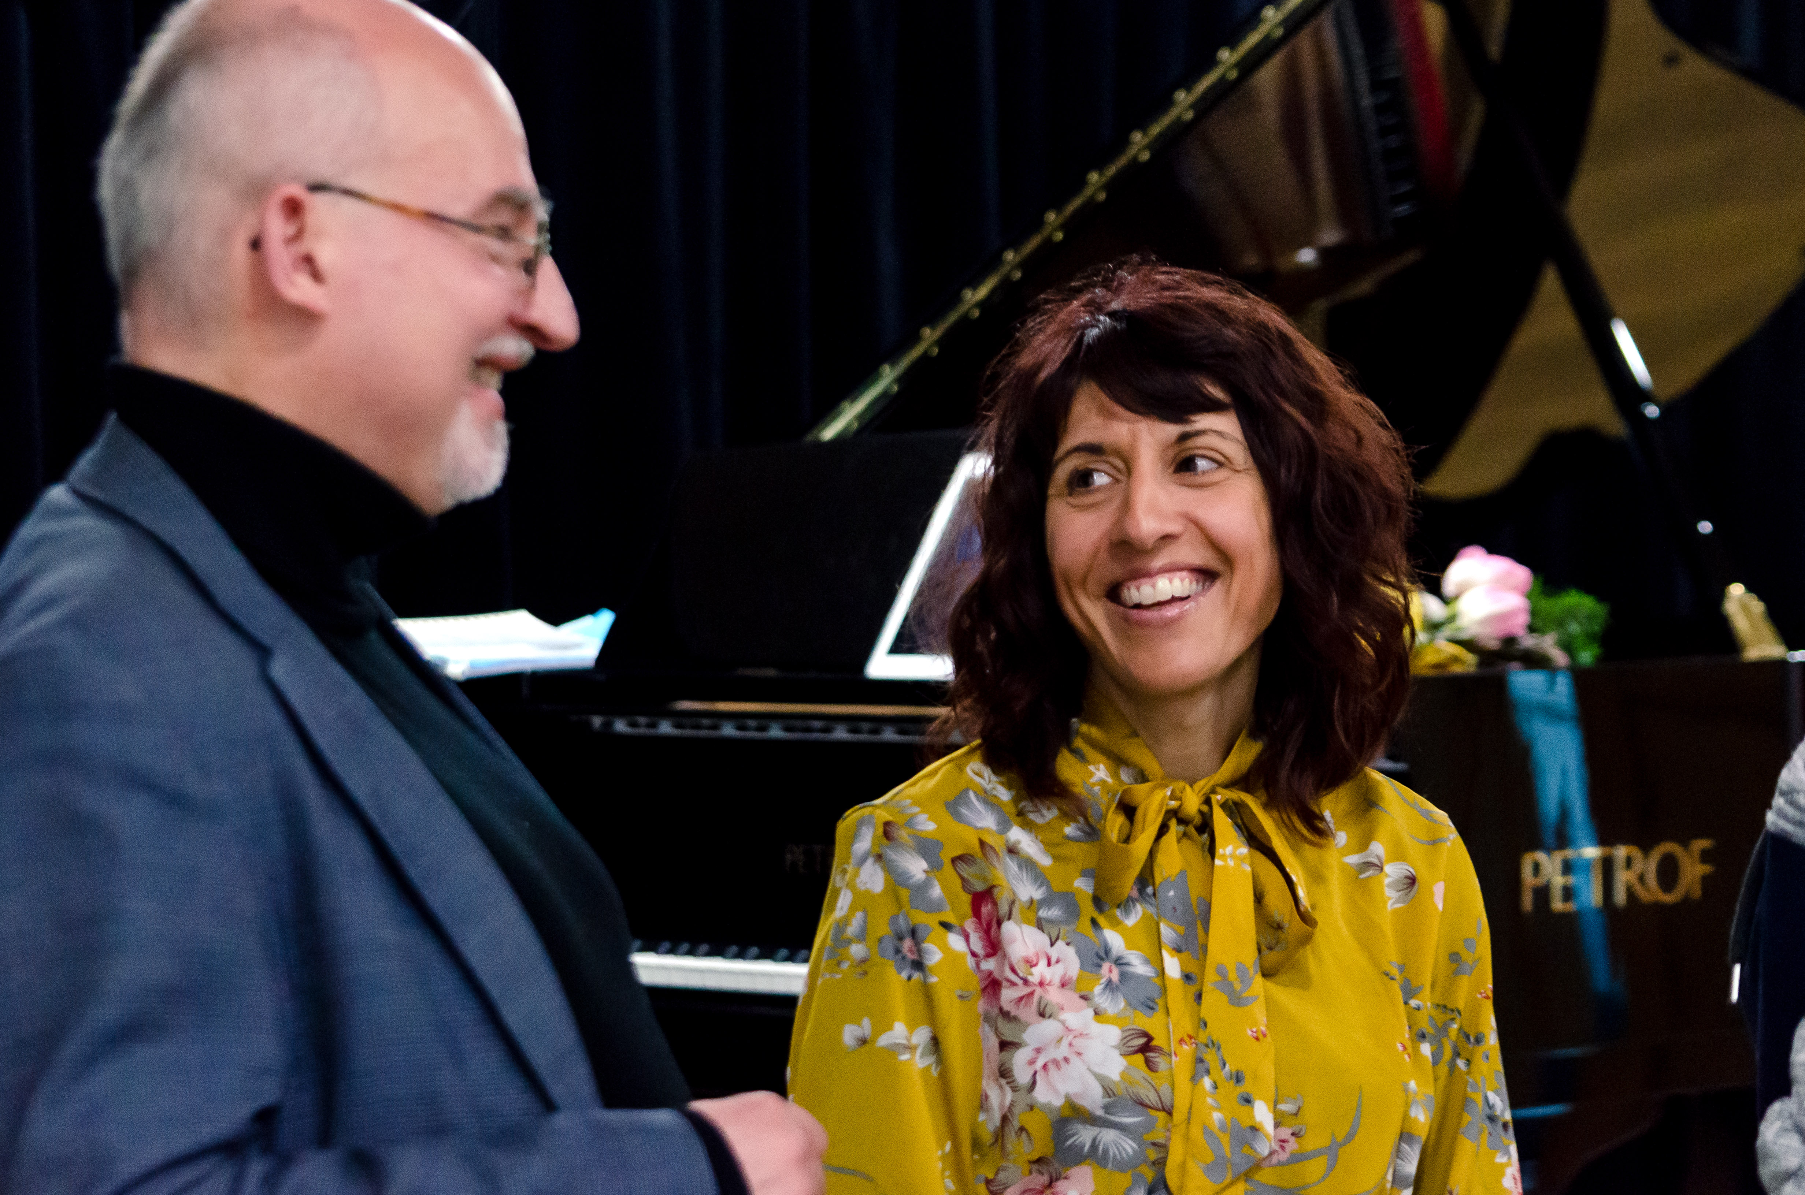

Composer Massimiliano Messieri, pianist Patrizia Romanello San Marino - Italy 2023

The center of the festival events became the end of May, the whole of June and the beginning of the holidays in Kroměříž.

The afternoon program on Saturday, May 27 at the Museum of Kroměříž was focused retrospectively on the creation of the composer **Ivana Loudová**, and became the beginning of the listening cycle called "We Don't Forget". Within its framework, a total of 9 similar programs were included in Forfest 2023. After Loudová, Milan Slavický, Jan Novák, Svatopluk Havelka, Rudolf Růžička, Petr Pokorný, Jan Hanuš, Petr Eben and Ilja Hurník were remembered during the coming weeks. All of these are the names of composers who, both with their compositions and their personal presence, made a significant mark in one of the past editions of the festival - they are no longer with us…

On the evening of May 28, was in the church of St. Morice is entirely dedicated to the legacy of the late František G. Emmert, a unique creator whose work is now gaining more and more popularity and has long since found its permanent place in Kroměříž's Forfest**. The Kroměříž** **Archbishop's Band** performed his Propria.

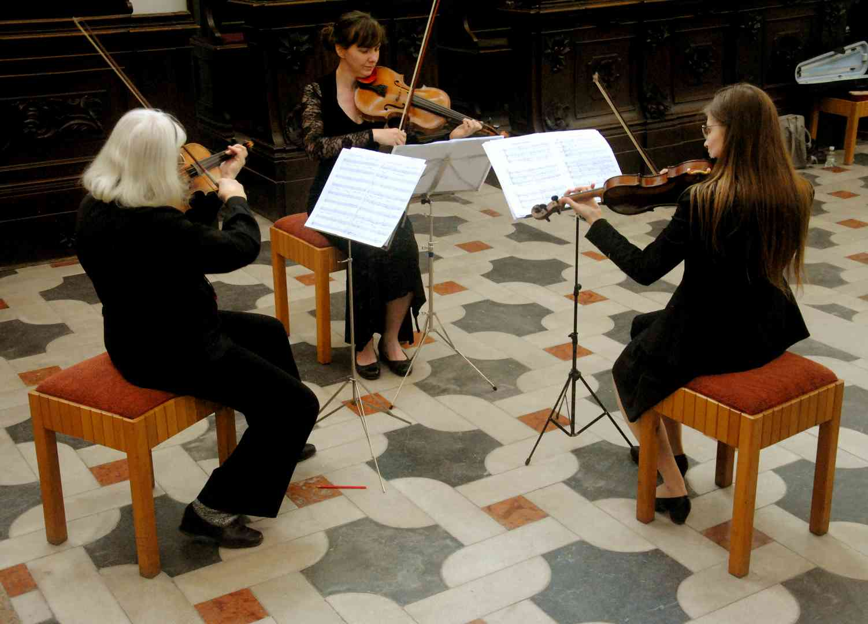

Author concert of František Emmert - Propria – Zdenka Vaculovičová, Anna Jeklová, Anna Hrušáková

On Sunday, June 4, Forfest moved to Olomouc, to Cathedral of St.Venceslav, where **Karel Martínek**'s author's organ recital was played. It was compiled entirely from sacred music, from the Epiphany Mass for organ, subtitled In Honor of Olivier Messiaen, and from 9 meditations about the mystery of the Holy Trinity.

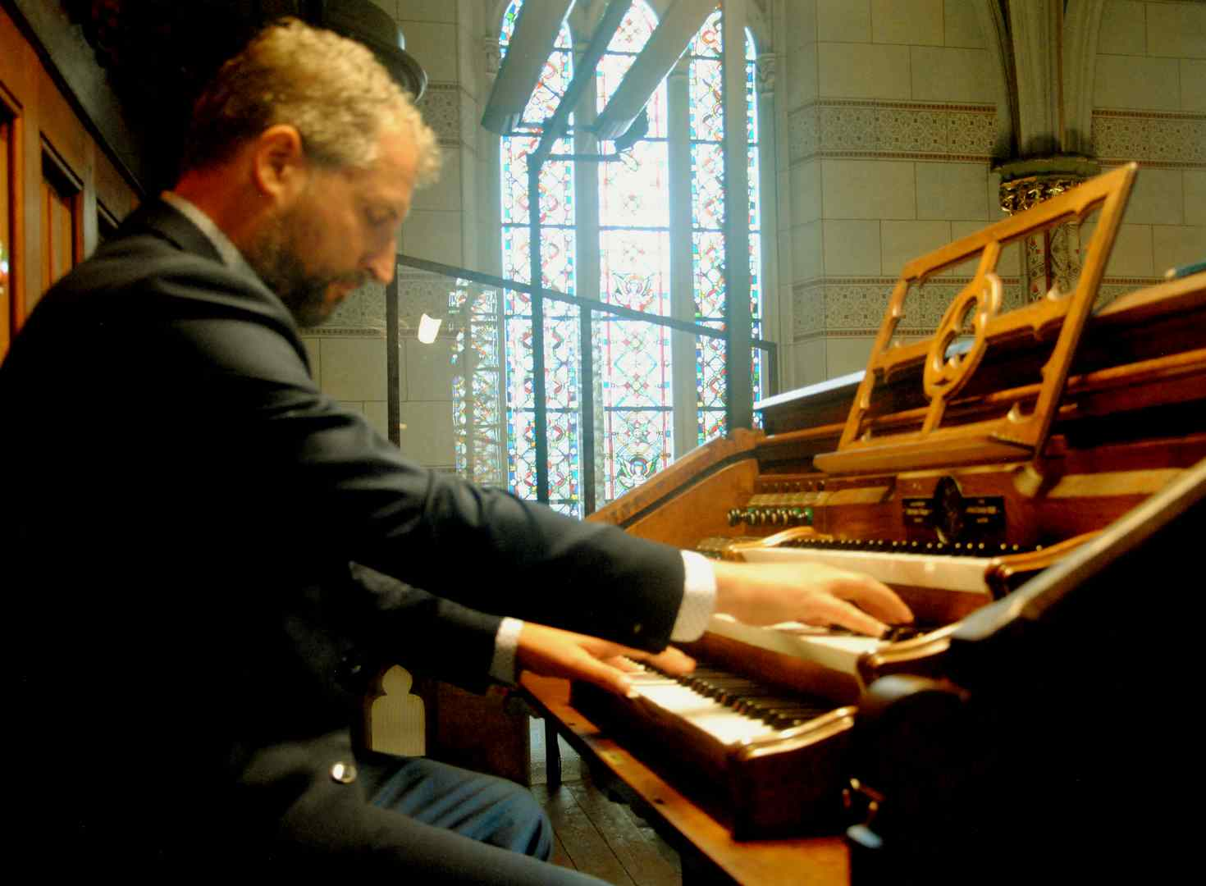

Karel Martínek - Cathedral of St.Wenceslas OLOMOUC

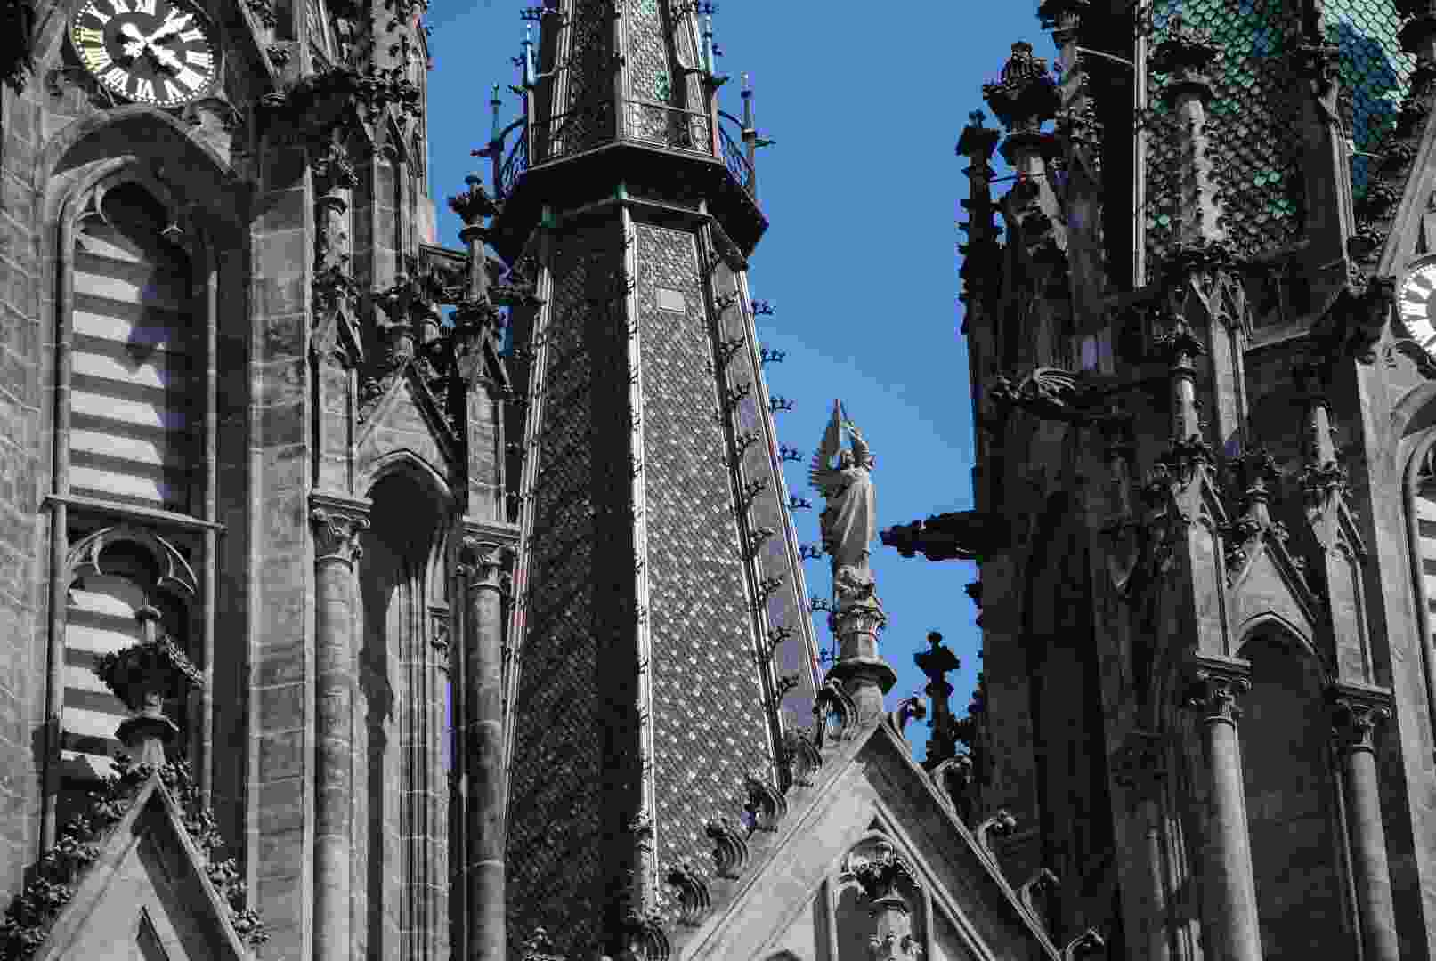

Facade of the Cathedral in OLOMOUC

The category of liturgical music also includes Missa brevis for solo soprano, tenor, mixed choir, organ and strings by **Zdeněk Král**. Again in Kroměříž on Sunday June 11, the Church of St. Maurice**, Lenka Cafourková – soprano, Jakub Kubín – tenor, Musica da camera** Brno, conducted by **Martin Franz**.

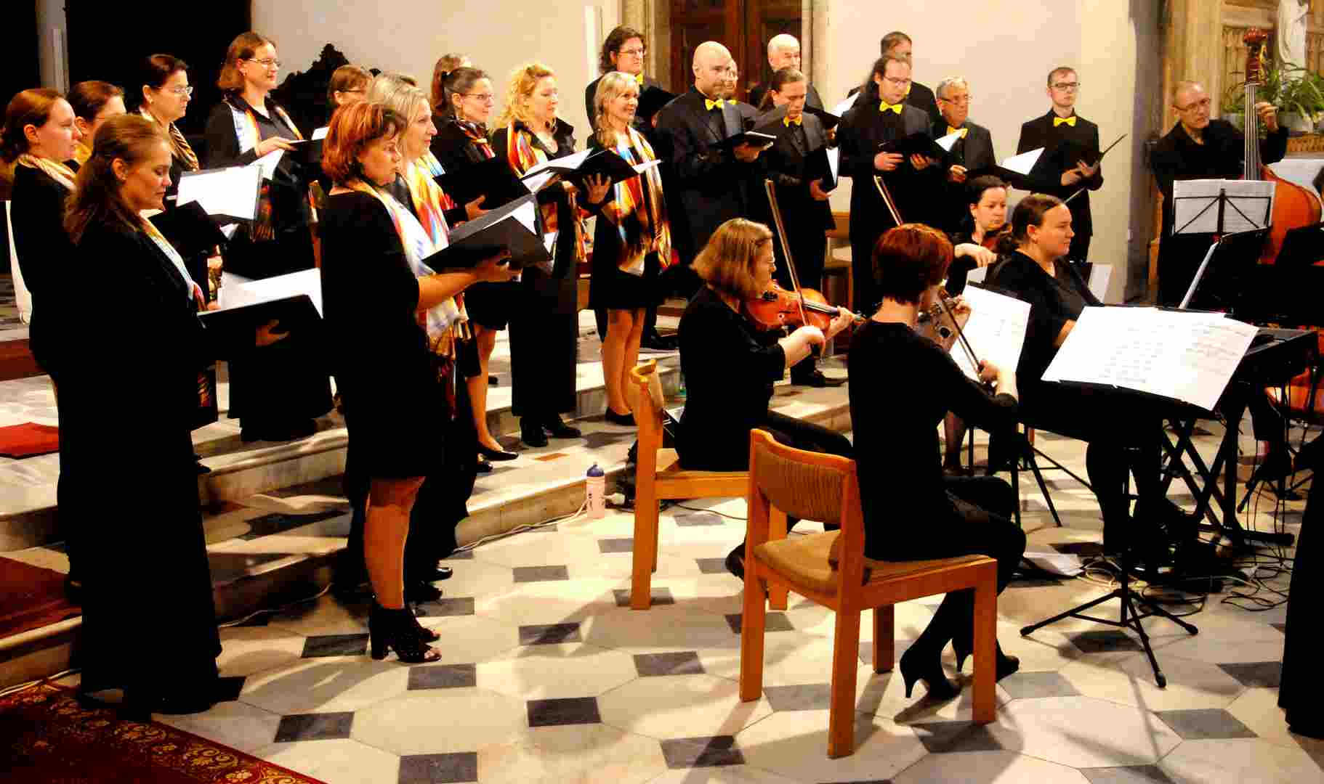

Musica da camera - Zdeněk Král – author concert 2023

A recital by the Czech-Slovak chamber duo **Eva Mokrá – viola** and **Katarína Ševčíková – harp** was performed in the exposition hall of the painter Max Švabinský in the Museum of Kroměříž on Saturday, June 17. The artists performed compositions with a pleasant and soothing expression by lesser-known authors. Their program included, among others, the work of **Bernard Anders, Evelyna Hubert**, **Paul de Senneville, Max Regr, Benjamin Britten** and **Katarína Ševčíková**. We heard not only the interplay of both, but also the solo performances of the female artists. The listeners were pleasantly surprised both by the musicianship of both performers and by their cultured appearance.

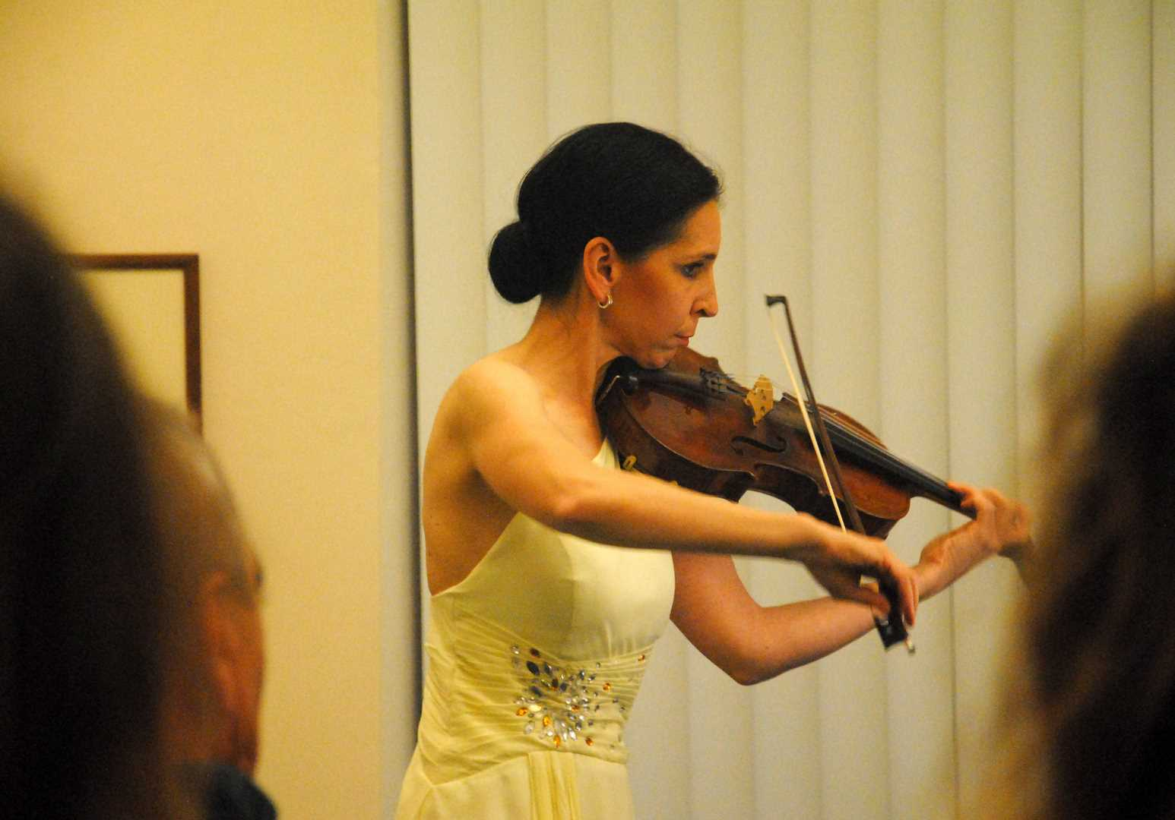

Eva Mokrá CZ - Museum of Kroměříž 2023

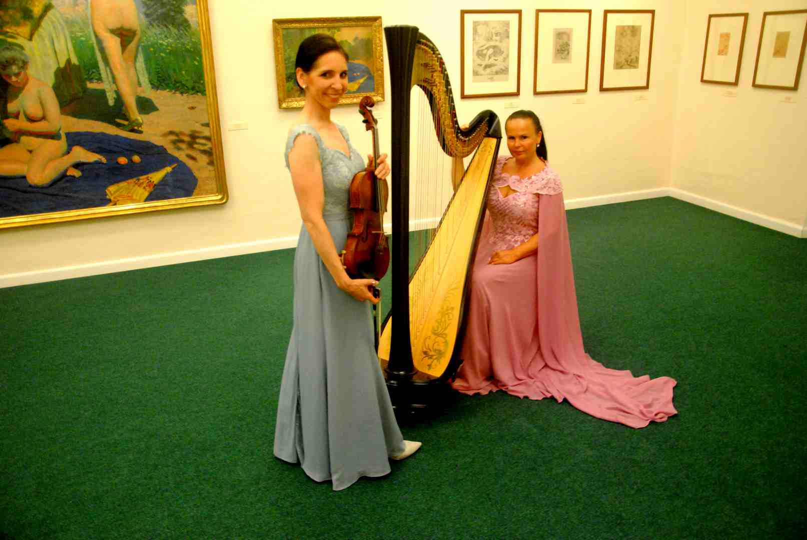

Eva Mokrá CZ - Katarína Ševčíková SK - Museum of Kroměříž 2023

Two Slovak artists, the soprano **Zuzana Barochová** and the organist **Ján Fic**, performed on Sunday, June 18, in the evening in the church of St. Morice, a selection from the spiritually focused work of three generations of Slovak authors. The oldest layer consisted of the work of Oldřich Hemerka (Ave Maria) and Josef Grešák (Prayer), the middle one by Josef Podprocký (Ave verum, Fantasy III) and Iris Szeghyová (Psalm for solo voice and Psalm 130), and the youngest was represented by **Peter Duchnický** (Fantasia Choralis), **Ivan Buffa** (Corale, Chaccone). Compositionally, **Iris Szeghy** stands at the highest level, the work of the youngest authors is characterized by overly traditional means of expression.

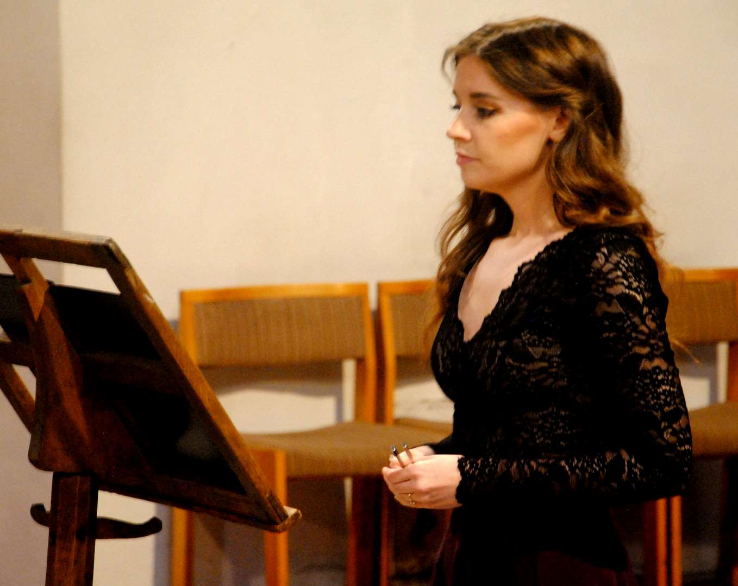

Zuzana Barochová - SK - soprano 2023

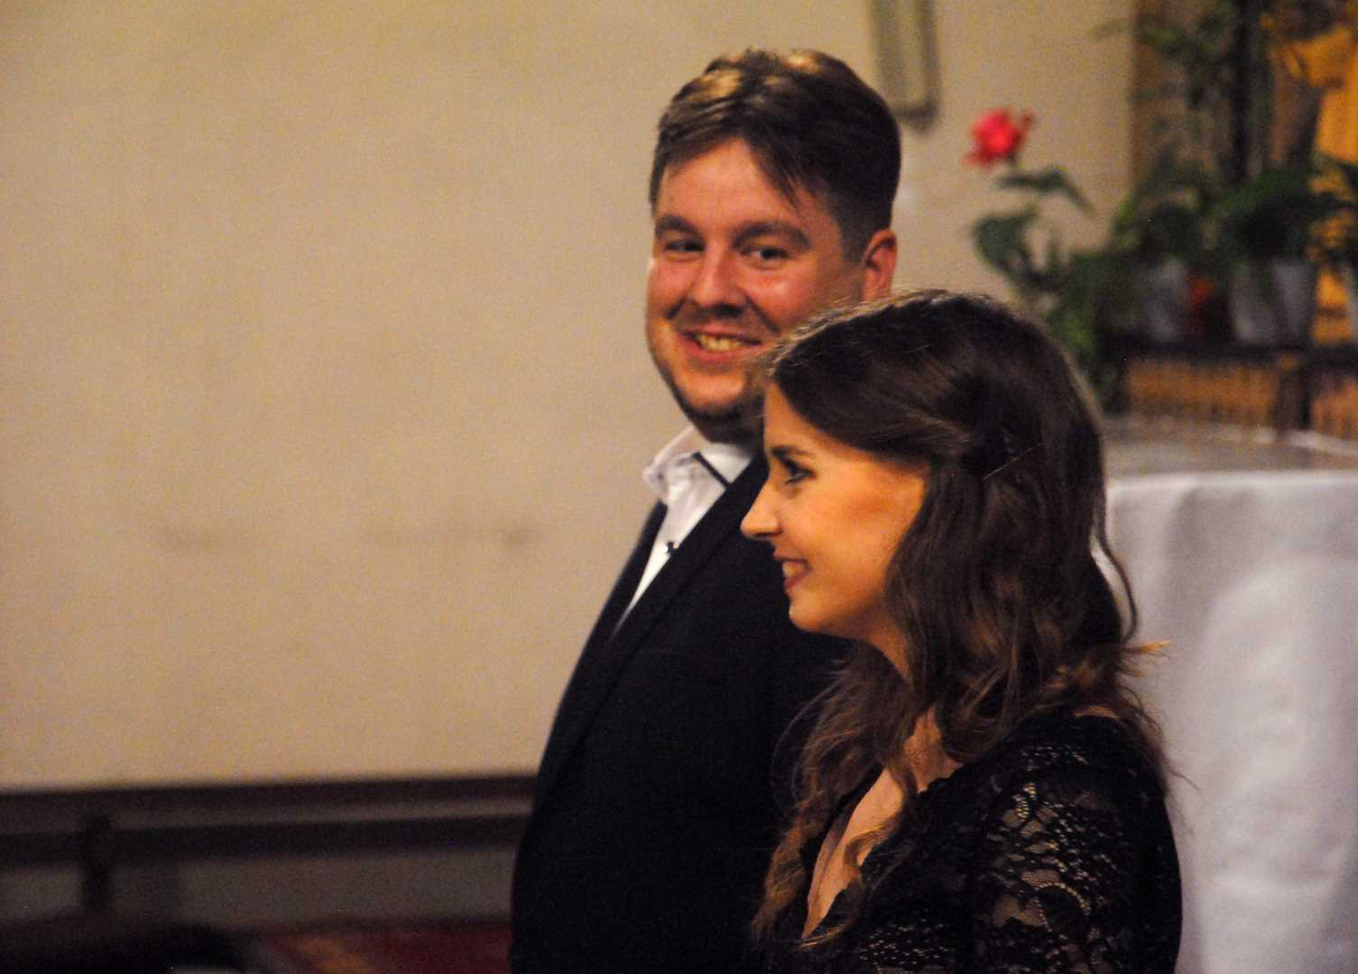

Zuzana Barochová - Ján Fic SK - after concert

Trio Lumae consists of recorder players **Lucie Lerlová, Magdaléna Klímová and Eva Polednová**. Trio was presented to the public at the Museum of Kroměříž on Monday, June 19, in the evening. As in the case of the viola-harp duo, this is an ensemble of an uncommon composition, so it is difficult to find a suitable repertoire for it. However, the advantage on the other hand is that lesser-known names will also get on the program, which is certainly a considerable benefit for the curious audience.

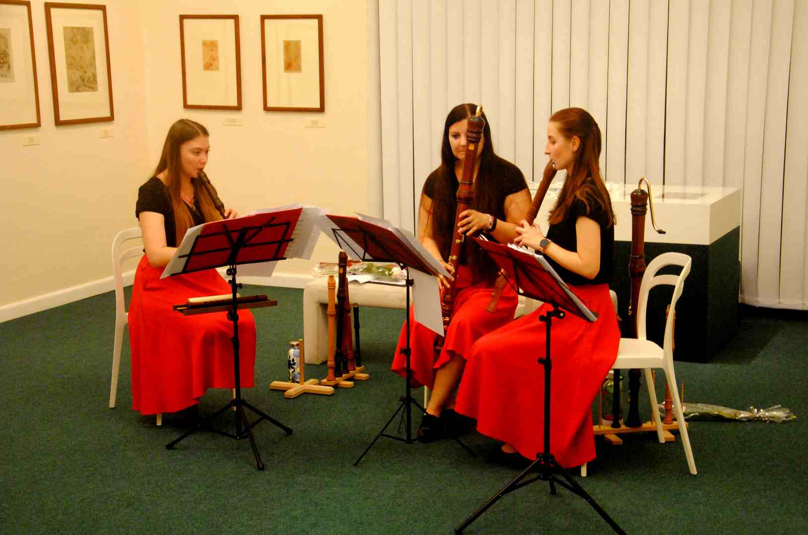

Trio LUMAE 2023 CZ

One of the undisputed highlights of this year's Forfest was the performance of the **Chamber Duo Hanuš Axman – clarinet and Jiří Lukeš – accordion** on Tuesday, June 20. We listened to them again in the premises of the Švabinský exposition of the Museum of Kroměříž. For the listeners, they discovered an unexpectedly close affinity between the two instruments, which includes the ability of fine articulation, a large dynamic and tonal range (Axman played not only the clarinet, but also the bass clarinet). Among other things, they compiled the program from the works of three Polish authors (Krzystof Penderecki, Witold Lutoslawski, Leszek Kolodziejski), two Czechs (Petr Fiala and Jiří Lukeš).

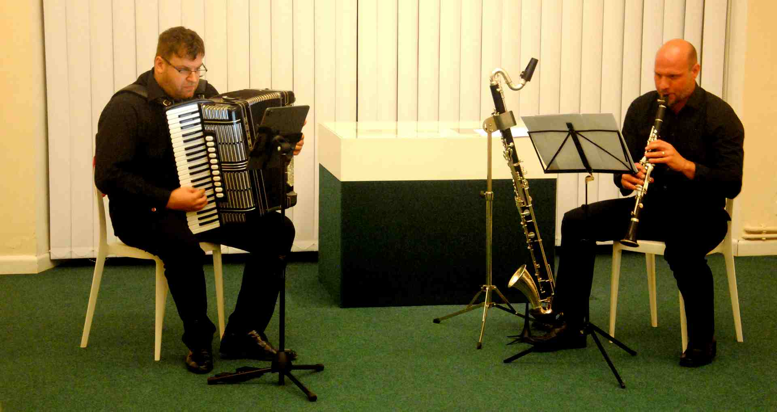

Jiří Lukeš - Hanuš Axman CZ

The solo recital of Slovak guitarist **Karol Samuelčík** was also of an unusually high standard. It took place on the evening of Wednesday, June 21, and the dramaturgy placed the whole of it, i.e. not only the performer, but also the audience, in an unusual and for many unexpectedly attractive space, in the chancel of the church of St. Morice. Samuelčík's presence in this year's Kroměříž was a hastily arranged stand-in for the originally announced performance of Duo Viento Marero. However, the result was not just some rescue, but a full-fledged experience of a first-class interpretation performance. With almost magical intensity, fine timbre nuances were created in the strings, which always only gradually faded away high in the ribs of the Gothic vault. Soloist performed compositions by **Marián Budoš, Jevgenij Iršai** and **Ján Králik**.

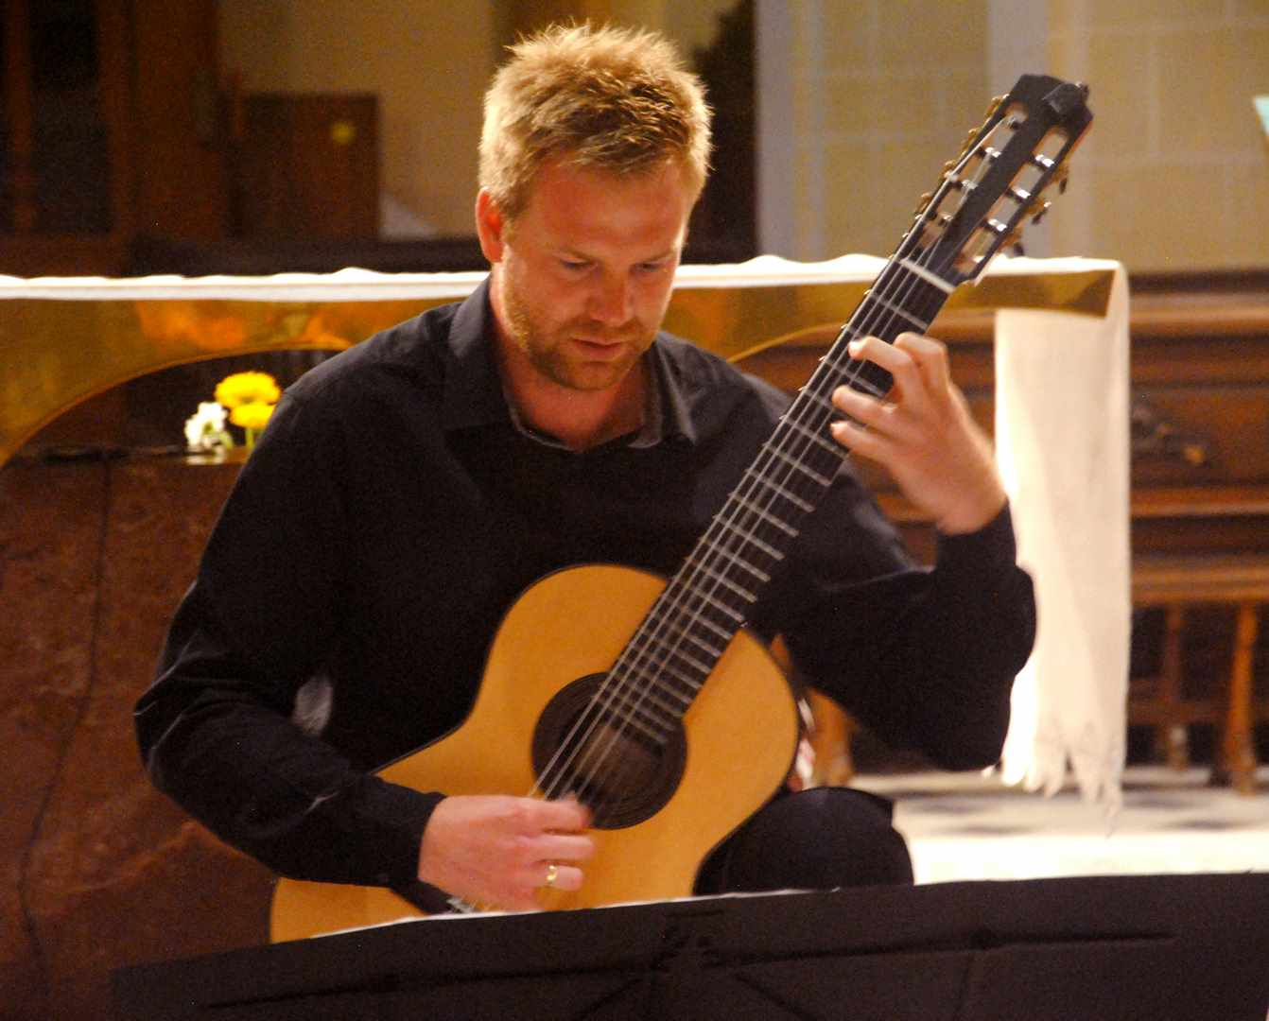

Karol Samuelčík SK 2023 – church of St.Morice

**Pavel Zemek** is a composer who has a very close relationship with the Forfest festival. This year, the whole of Thursday, June 22, was reserved for him. First, in the afternoon in the Garden Studio, he talked with friends about his extensive composition Isaiah's Prophecy, then, in the evening, he was present at the launch of this work in the Church of St. Moritz. It is a composition with an original concept, built on an instrumental unison, whose ideological source is the Gregorian chant. The author bases his idea not only on spiritual inspiration, but also on ingenious and subtle instrument combinations, which, of course, are not so easy to implement in a regular concert setting. Therefore, it is only possible to consider a carefully arranged studio recording of the work, made by experienced performers and good sound masters, as a representative and definitive completion of the author's efforts. Therefore, if the listeners now heard the composition from a sound recording in Gothic architecture with colorful acoustics, it cannot be considered just a substitute or a dramaturgical deficiency, but on the contrary a completely logical and impressive completion of the author's creative intention.

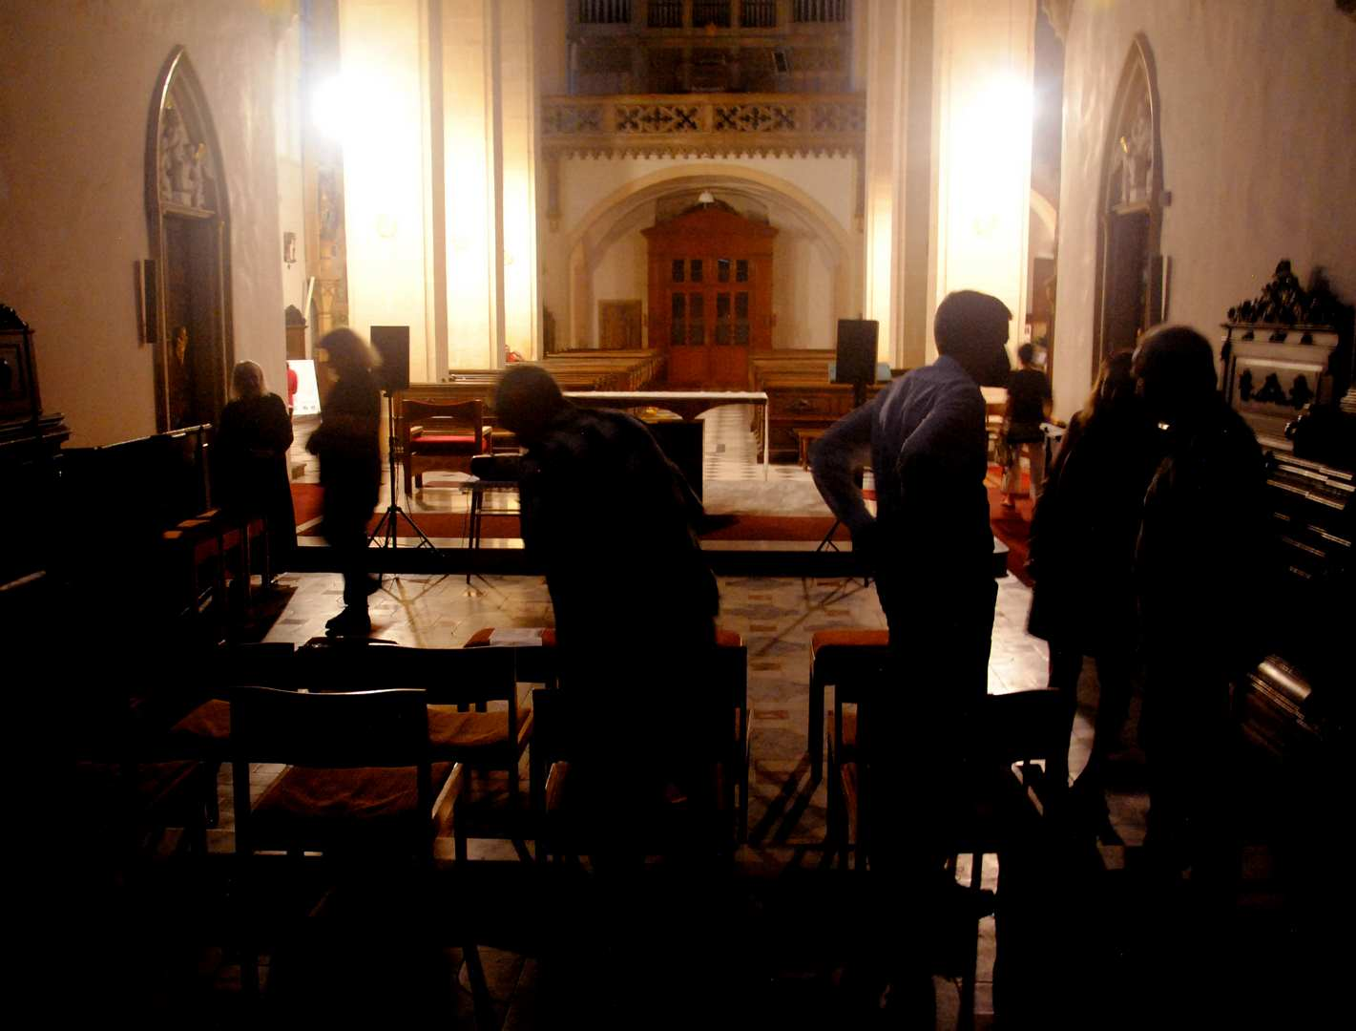

Pavel Zemek - Isaiah's Prophecy - Church of St. Maurice 2023

On Friday, June 23, a solo recital by another Slovak string artist, the violinist **Milan Paĺa**, was also held in the expanded St. Morice church space, and he performed the composition Touches, Behind the Mirror by **Adrián Demoč**. This is a work from the category of minimal music, where the author filled the space of a full-length concert with just one musical idea, a stereotypical sequence of different flagolet tones in a low dynamic position. In the space under the high Gothic vault in the gradual evening twilight, it had a suggestive effect at first, however, as soon as the listener understood the compositional intention, which happened after about 10 minutes of the production, the rest of the evening became somewhat boring for him musically.

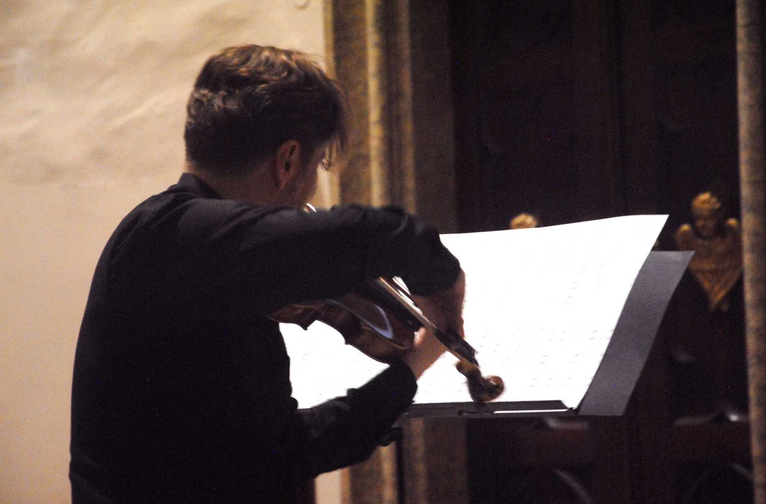

Milan Pala SK - Church of St. Maurice 2023

On Saturday morning, the Japanese artist MgA. **Julie Okaji** performed at the Kroměříž Museum. She performed six short compositions on the electric piano, mostly in a neoclassical style. She played Czech authors (Leon Juřica), but especially Japanese authors (**Matsumura, Ikeda, Hisaishi**), in whose compositional thinking we find influences from the Orient as well as the European tradition.

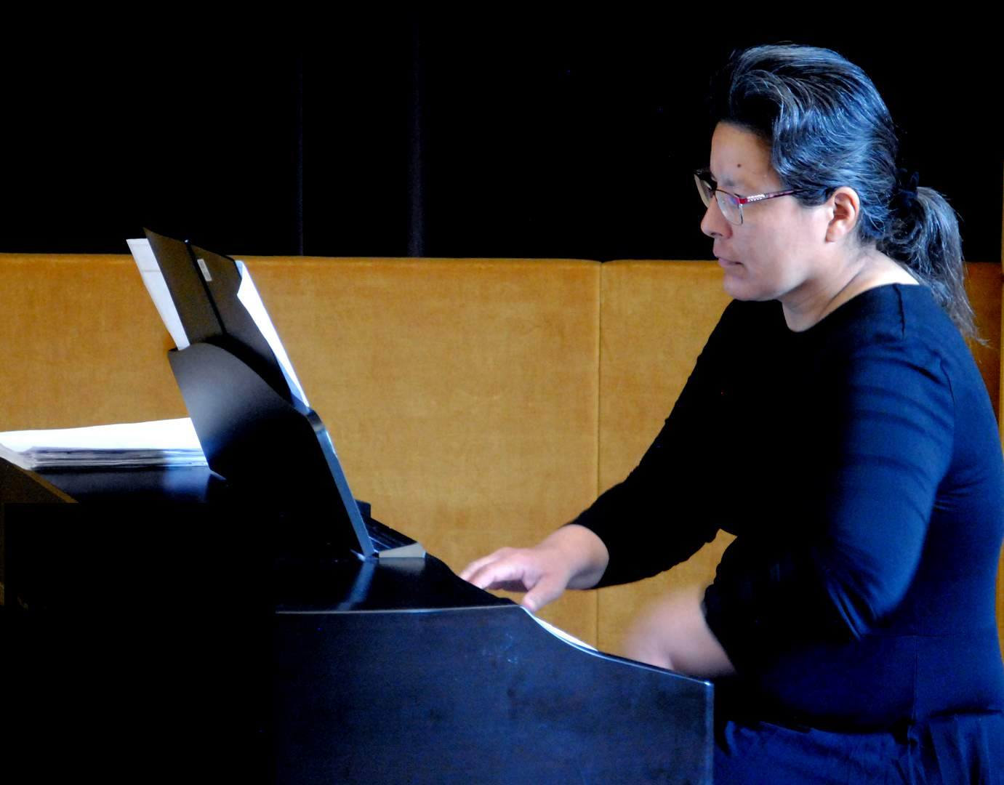

Julia Okaji - Japan - Museum of Kroměříž 2023

The sound project of three Brno artists, **Vít Zouhar, Gabriela Coufalová and Jaromír Synek**, called ROZ JA SNĚNÍ, can be considered as a certain counterweight to Demoč's Touches. He, too, is divided into long, continuous areas with mostly low dynamics, set in the impressive environment of the nave, this time not Gothic, but Baroque. This is an electroacoustic composition. Right on the spot, i.e. in the premises of the Church of St. John the Baptist was presented and completed by all three of its authors from behind computer facilities. The essence of this performance was detailed work with sound matter of an exclusively non-tonal nature.

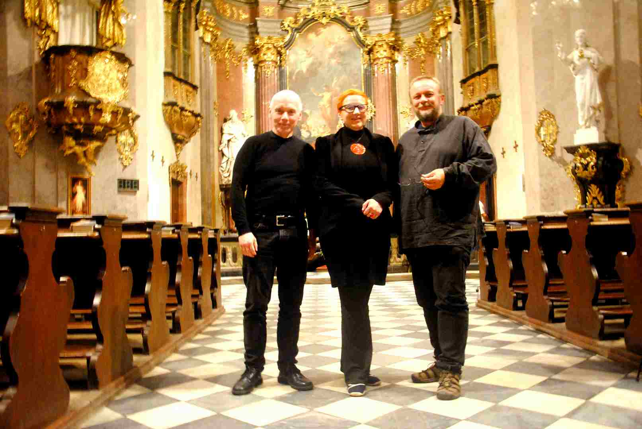

Vít Zouhar - CZ - author concert project 2023 - Vít Zouhar, Gabriela Coufalová and Jaromír Synek

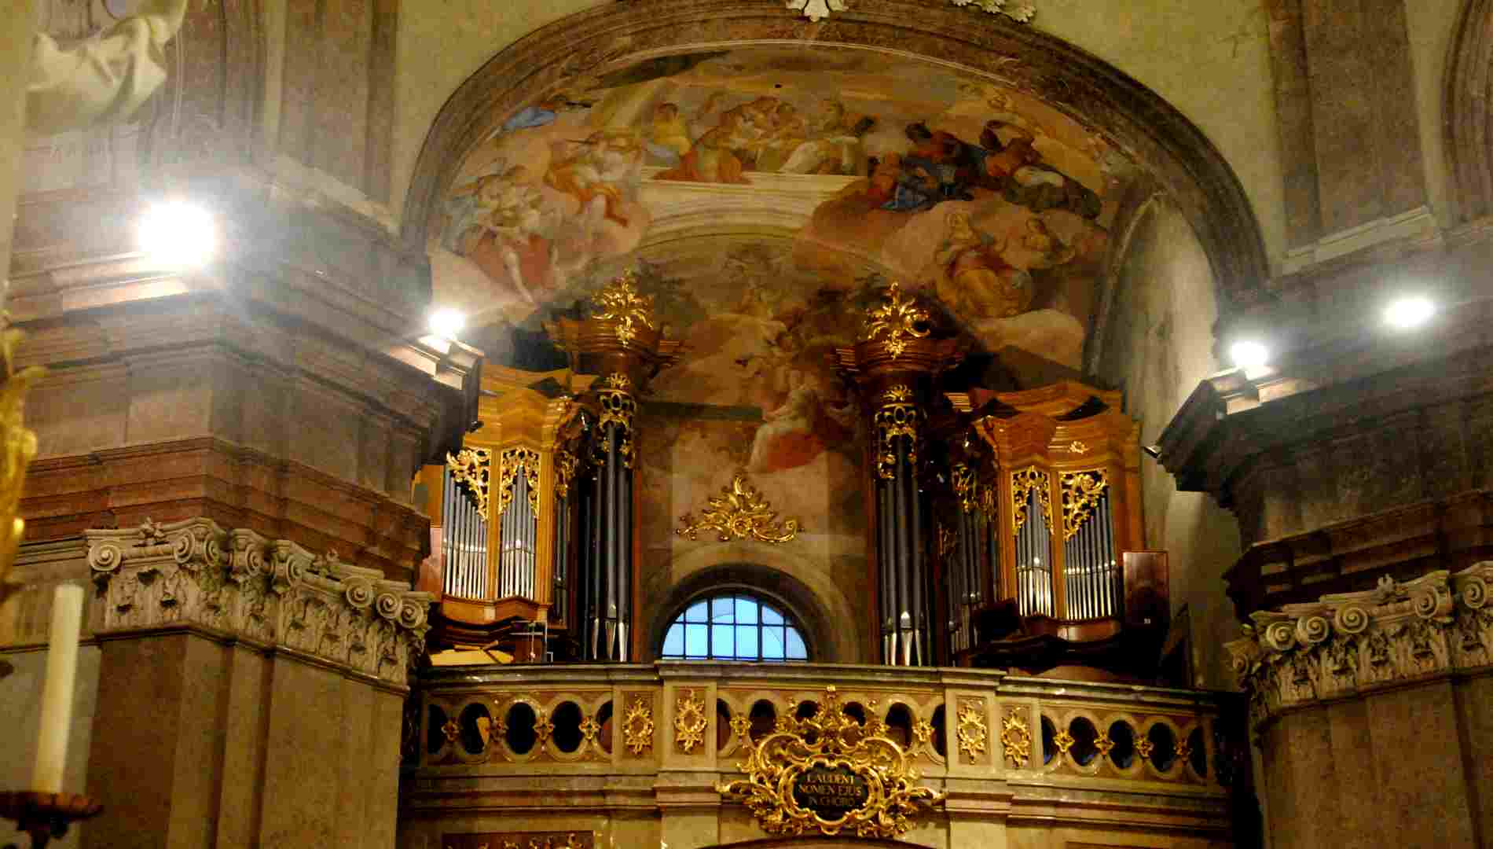

Church St.John Baptist 2023

An important addition to the mainly Catholic-oriented focus of the festival dramaturgy was the inclusion of a guitar concert by the evangelical clergyman **Pavel Čáp**, who on Sunday, June 25, presented his program, composed of compositions by 12 authors, in the Jan Blahoslav Church Choir. It was mostly about instrumental trifles, compositions reflecting the Czech spiritual tradition going back to Master Jan Hus, Bílá Hora and Czech fraternal songwriting. The performer explained the historical and theological connections to the listeners in an engaging and qualified manner, as well as the artistic inspirations of the composition Impetus by **Vojtěch Mojžíš**, the most extensive work of his program.

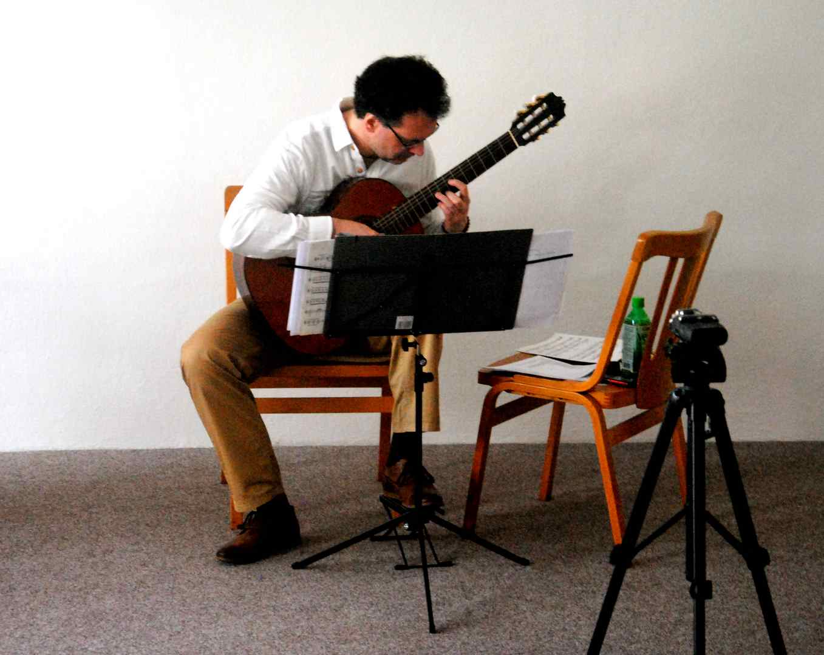

Pavel Čáp CZ - Choir of Jan Blahoslav 2023

Again in the Catholic spirit and in a Catholic environment, in the temple of St. Morice on Sunday evening (June 25), the author's evening of the young Brno composer **František Fiala** took place. This author focuses primarily on the creation of spiritual music, and he also designed his performance at Forfest this year in this direction. When putting together the program, he made full use of the operating possibilities offered by the Gothic architecture of St. Morice: solo organ sounding from the choir (Biblical images for solo organ), solo organ and at the same time a schola standing below in front of the altar (Christ as an example of humility). Chamber vocal-instrumental performance with piano in front of the altar (I live like lifeless), girls' choir with choir organ (Ave verum corpus), trumpet and choir organ (Mysterium paschale). The organization of this program was definitely not easy, choristers from Prague (**Schola strahoviensis**), a girls' choir from Brno (**Ensemble versus**), the great **Lucie** **Laubová - soprano, Petr Hojač - trumpet, Petr Rajnoha - organ** and the composer himself - **František Fiala** - had performed on synthetic piano and the organ. The success of this evening was due not only to Fial's compositional art, but also to the unbridled enthusiasm of all the performers.

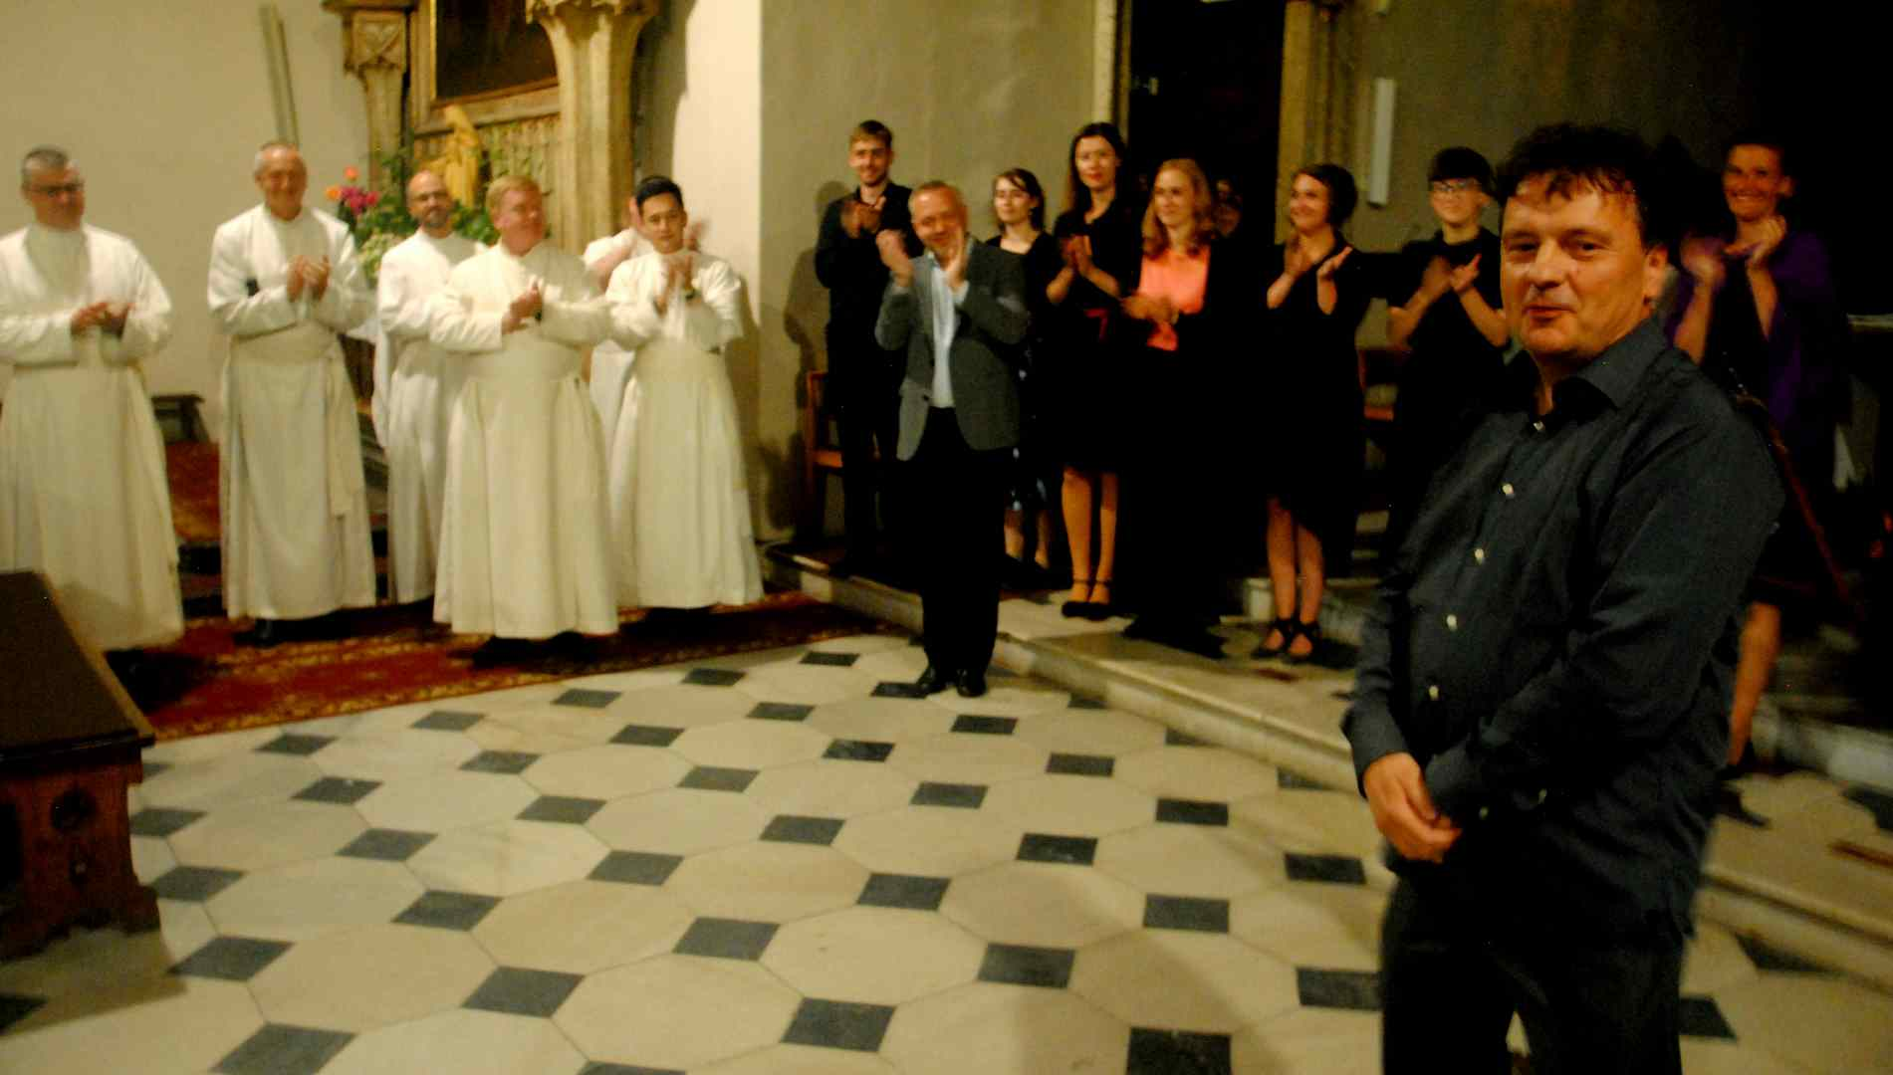

František Fiala CZ - author concert – church of St. Maurice 2023

On the afternoon of Tuesday, June 27, concert of chamber duo - American flutist **Daniel Kessner** and French guitarist **Philippe Rayer** - took place in a chamber environment, in the Koroměřížska Museum, which is already inextricably linked with the musical and musical theoretical activities of Forfest. **Daniel Kessner** brilliantly controls and purposefully alternates flutes of three sizes, thereby expressively expanding the scope of his instrument field. He also introduced himself as a composer (Fleeting Episodes for bass flute and guitar and Études de concert for solo guitar). He proved that he is no stranger to both jazz (Jazz Dream for solo bass flute) and oriental inspirations (Toru Takemitsu: Toward the Sea for alto flute and guitar). The inclusion of the works of **Gabriel Fauré** (Siciliane) and **Jacques Ibert** (Entr´acte) is undoubtedly related to the homeland of guitarist Philippe Rayer.

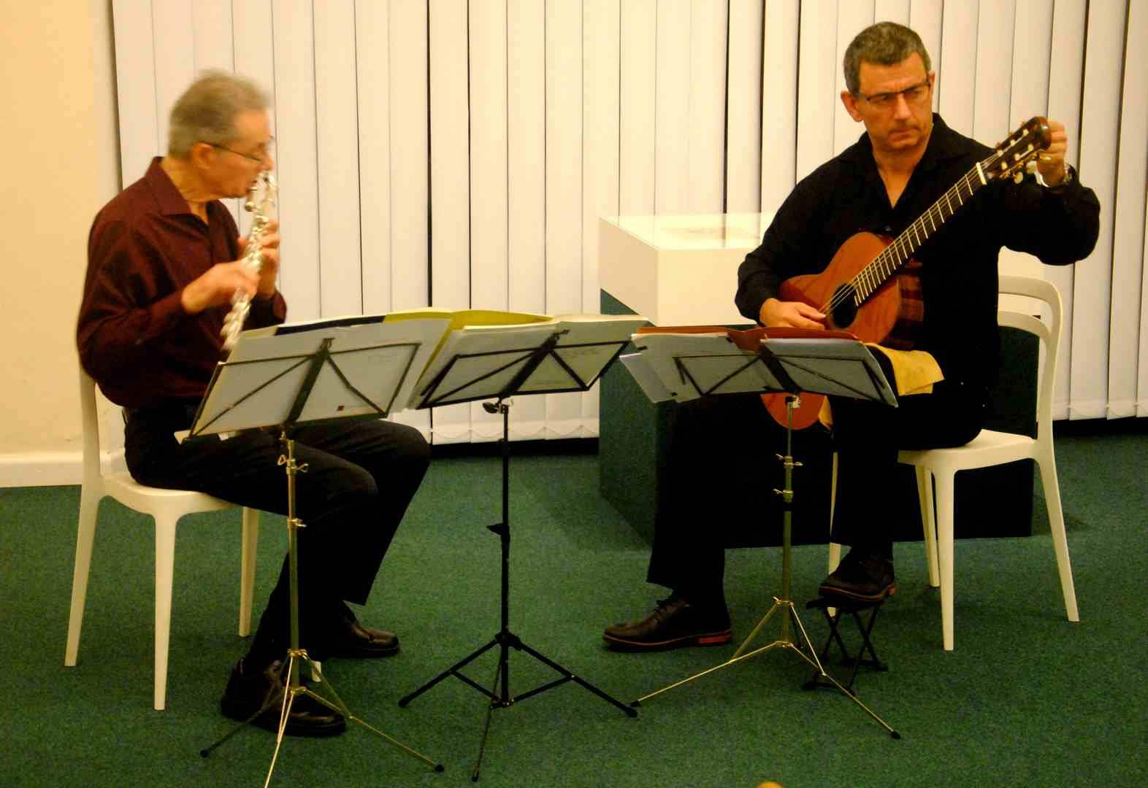

Daniel Kessner - USA, Philippe Rayer - France 2023

The organizers of Forfest paid well-deserved attention to the life story and work of the Pilsen composer, writer and patron, **dr. Karel Pexidr.** On the afternoon of Saturday, July 1, a listening program was dedicated to him at the Museum of Kroměříž.

**Massimiliano Messieri** is a composer who has been loyal to Forfest for years. In previous years, he presented himself in Kroměříž, for example, with his instrumental work connected to an electro-acoustic component. This year, his two chamber compositions (Ricordando il passato and Lirische Sacre – eleven verses from the Old Testament for soprano and chamber ensemble) were premiered at the afternoon performance of the multinational group **OYO Our Youth Orchestra** on Saturday, July 2 in the Church of St. Morice. This concert was the complete conclusion of the central, time-concentrated period of festival activity, located at the turn of June and July. It was compiled from the contemporary work of North American and European composers (**Terry Riley, Arvo Pärt, Béla Kováss, Ivan Trevino**).

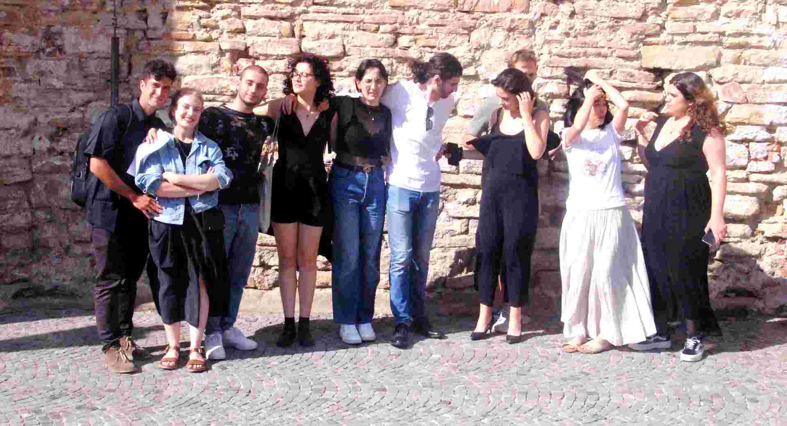

OYO Our Youth Orchestra JPN-RUS-ITA-RSM 2023

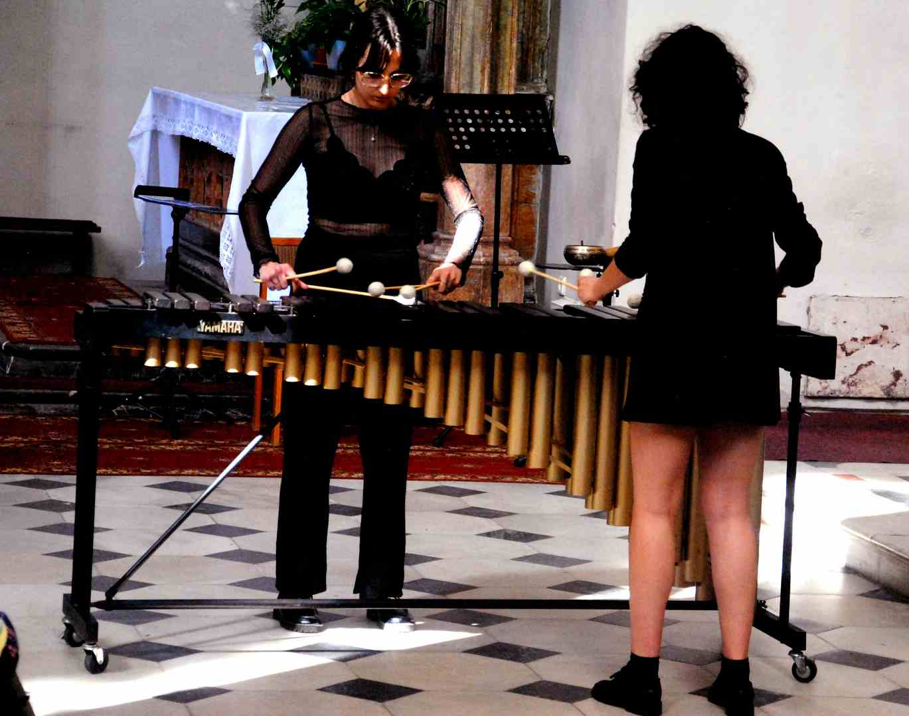

OYO Our Youth Orchestra 2023 - Lin Gabrieli and Giorgia Nina, marimba

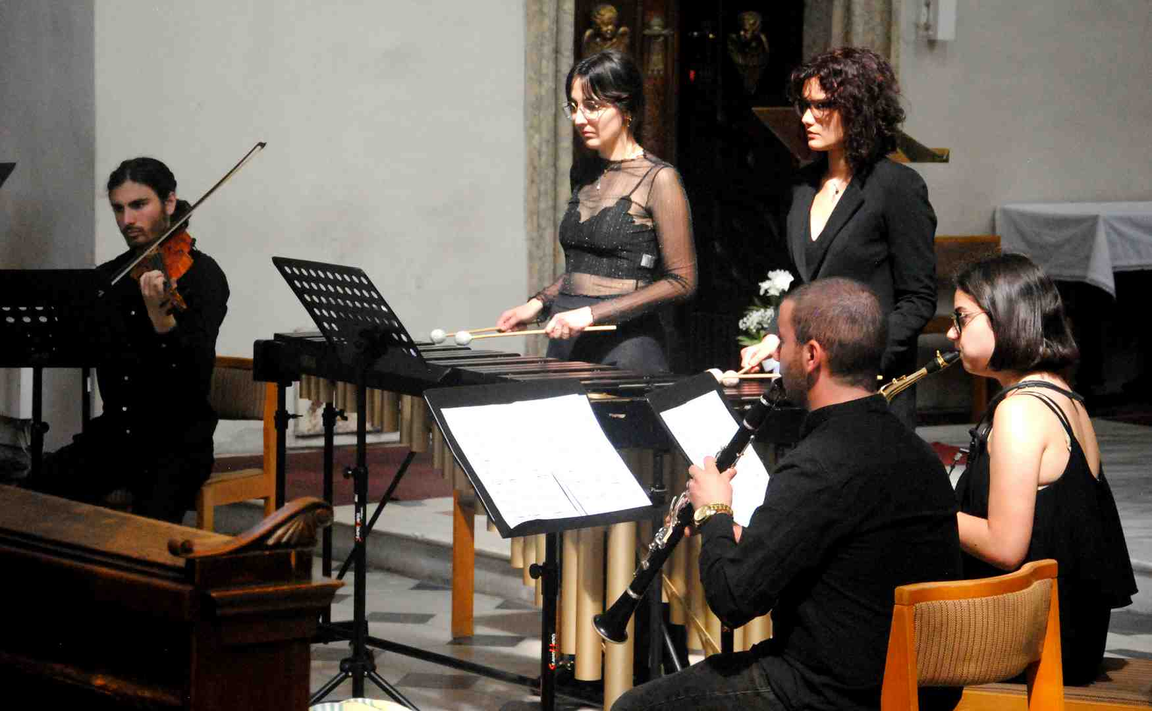

OYO Our Youth Orchestra – San Marino 2023

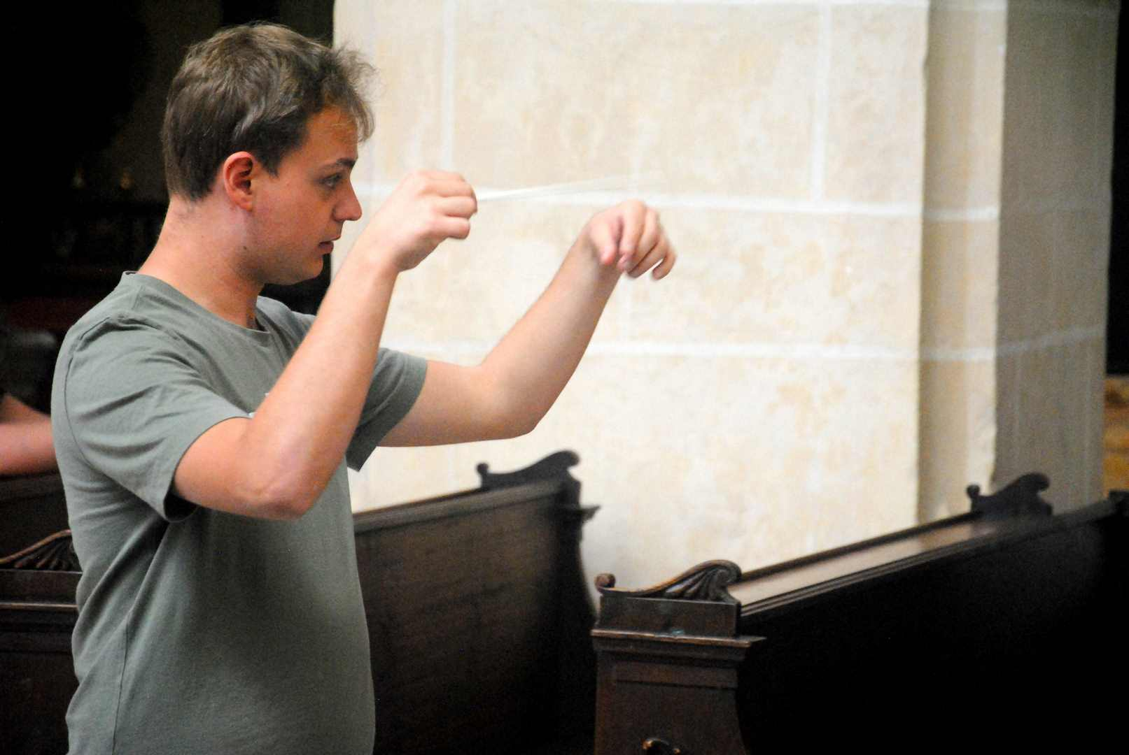

OYO Our Youth Orchestra 2023 - Mario Pesaresi - conductor – rehearsal

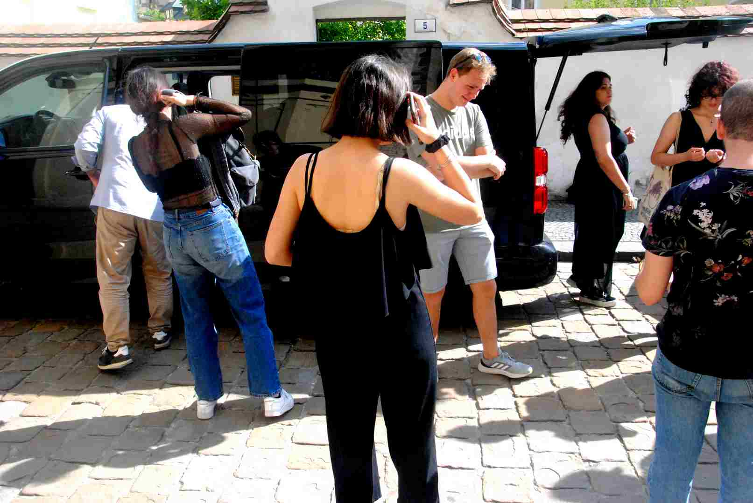

OYO Our Youth Orchestra 2023 - after concert

Forfest 2023 immediately continued in other forms and under a different name, as POSTFEST. Already on July 3, traditional courses for young composers were launched in the premises of the Jan Blahoslav Choir on Riegrová náměstí in Kroměříž. This year, the teaching team is also made up of experienced music educators who are close to the idea of Forfest. **Pavel Zemek** came from Brno, **Ondřej Štochl** from Prague, the Russian school of composition is represented by **Yevgenij Iršai**, and **Albert Breier** from Germany. They certainly had something to say to young adepts of the art of composition.

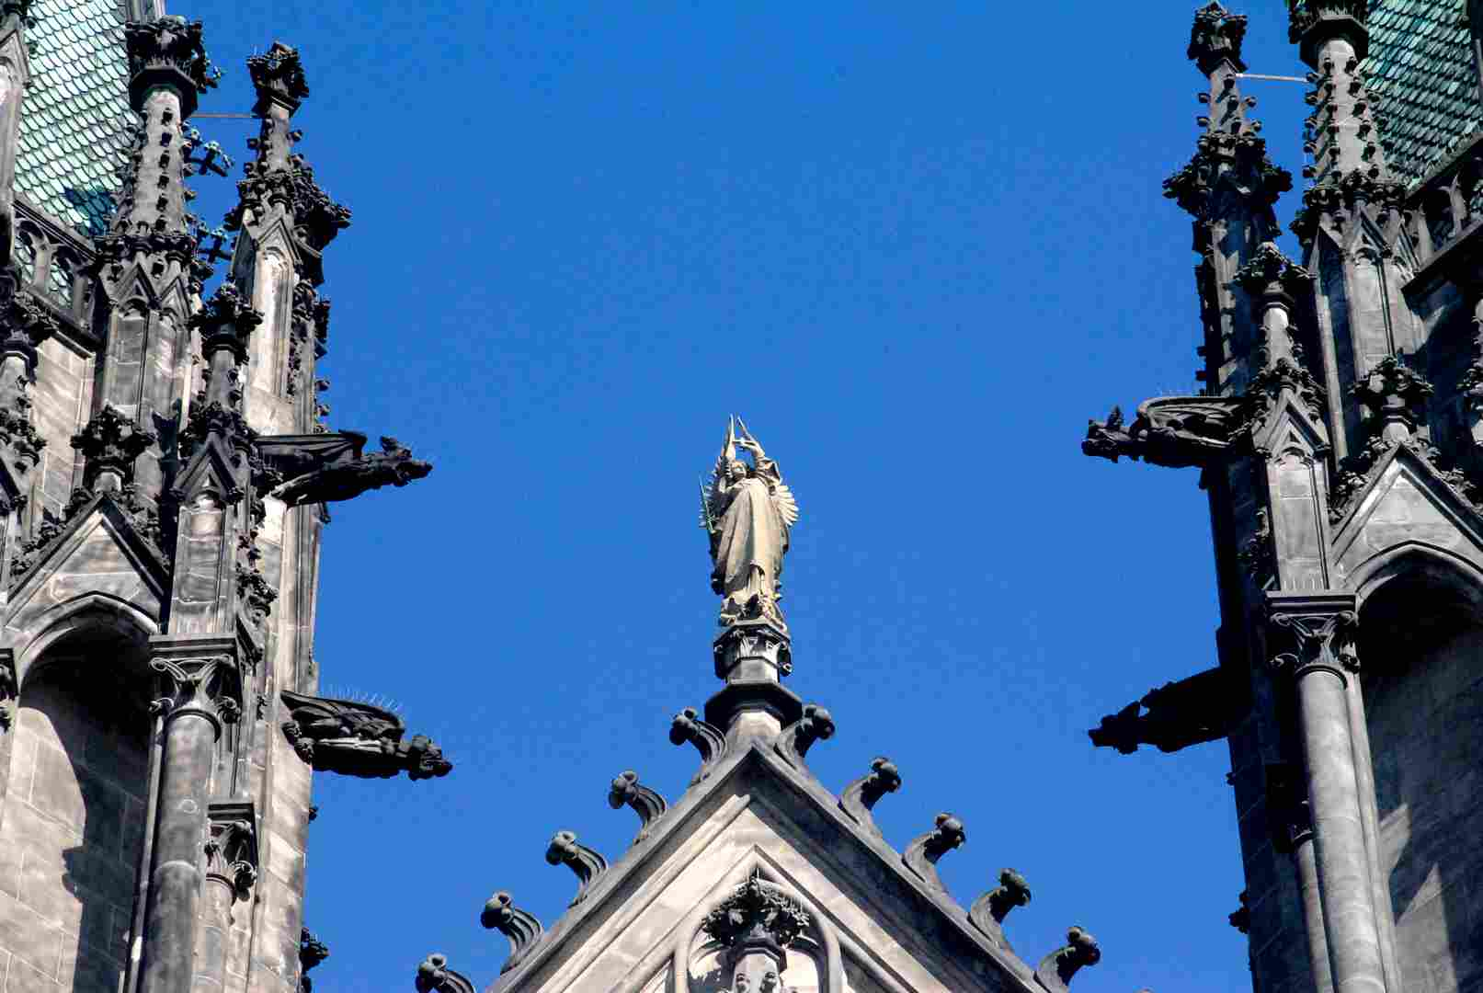

Cathedral of St. Wenceslas in Olomouc - detail of the facade